**Project Report**

Company: Britania Retail

Date: October 20, 2025

Project: Understanding Sales and Customer Habits

**1. Summary for Managers**

This report analyzes our sales data to find what works and what doesn't.

The most important finding is that **Marketing Spend is the #1 reason sales go up**. Our new computer model shows that spending more on marketing has 2.7 times more impact on sales than getting more people to visit the store.

On the other hand, our **current discount strategy is not working**. It doesn't seem to increase sales at all. In fact, it might even be hurting sales slightly. What competitors do with their prices doesn't seem to affect us much either.

Our main advice is to **spend more money on marketing** and **completely rethink our discounts**. We could even move money *from* discounts *to* marketing.

Based on this, if we increase marketing by 10% next month, we predict sales will be around **$1,728,739.73**.

**2. Project Goal**

The goal was to answer a few key questions for management:

* What really causes our monthly sales to change?
* Do marketing, store visits, and discounts have a strong link to sales?
* Can we build a tool to predict next month's sales?
* How can we show these results in a simple way?

**3. How We Did It**

We used the Python programming language to analyze the data.

1. **Data:** First, we loaded all the sales data from our company database.
2. **Charts:** We made charts to see the data and find patterns.
3. **Prediction Model:** We built a "Multiple Linear Regression" model. This is a computer program that learns from our past data to see how much each factor (like marketing or discounts) impacts sales. We "standardized" the features, which just means we put them all on the same 1-10 scale so we could fairly compare their impact.

**4. What We Found in the Data (The Charts)**

**Sales Revenue Over Time**

Sales are **very up-and-down**. The chart shows sales bouncing quickly between $1.0M and $1.9M. There's no smooth, steady growth. This suggests sales are driven by short-term things, like ad campaigns.

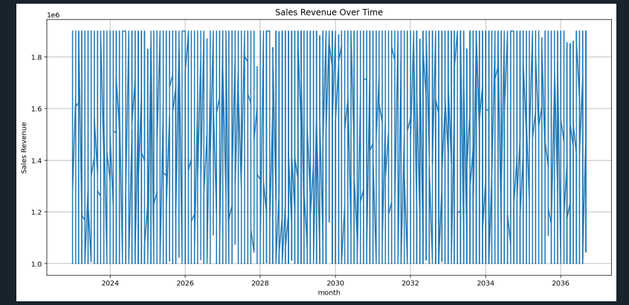

**Store Visits**

The number of people visiting our stores **changes a lot month-to-month**. There isn't one "average" number of visits. We have some months with low traffic (around 7,200) and some with high traffic (around 11,500).

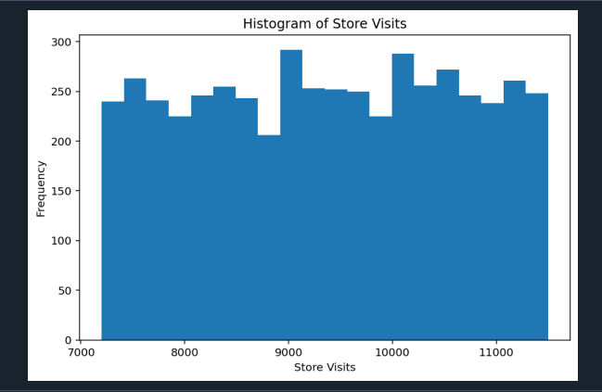

**Marketing Spend vs. Sales Revenue**

This chart shows a **clear link: more marketing equals more sales**. As marketing spend (bottom axis) goes up, the sales (side axis) also go up. It's not a perfect line—other things still matter—but the trend is obvious.

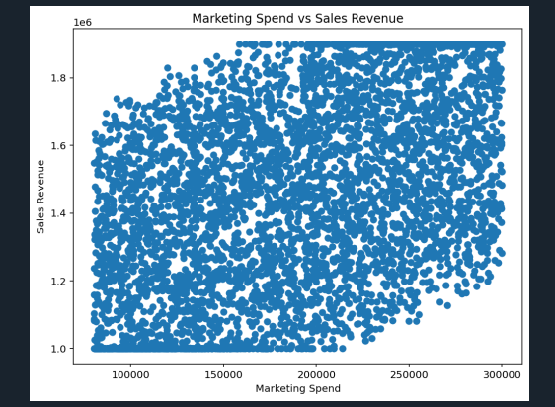

**Correlation Heatmap (How Things Move Together)**

This special chart uses colors to show how strongly two things are linked. Red means they move together; blue means they don't.

* **Strongest Link:** **Marketing_Spend** has the highest positive score (**+0.49**). This confirms it's the most important partner to sales.
* **Weak Link:** **Store Visits** has a small positive score (**+0.19**). It helps, but not as much.
* **No Link:** **Discount_Percentage** (–0.01) and **Competitor_Price_Index** (–0.02) are blue, with scores near zero. This is a huge finding: **discounts and competitor prices have no real link to our sales**.

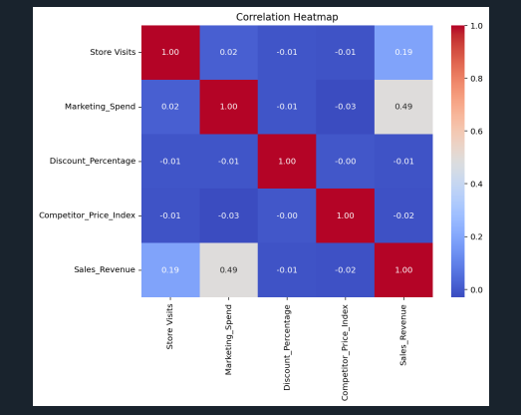

**5. The Prediction Model (What It Told Us)**

We trained a model to predict Sales_Revenue. Here is what it learned.

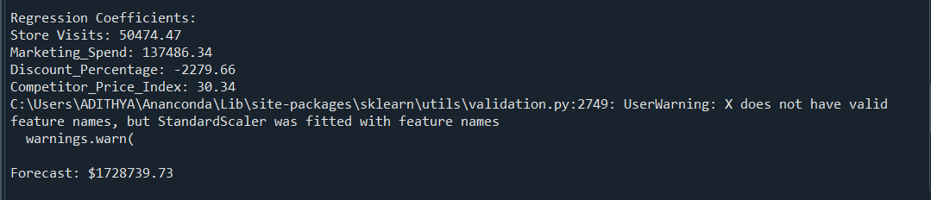

**Impact Scores (Coefficients)**

These scores show how much $1 "unit" of spending on each feature (on that fair 1-10 scale) affects sales:

* **Marketing_Spend:** **$137,486.34**
* **Store Visits:** **$50,474.47**
* **Competitor_Price_Index:** **$30.34**
* **Discount_Percentage:** **–$2,279.66**

**What this means:**

* **Marketing is the clear winner.** An increase in marketing has the biggest positive effect on sales.
* Store Visits are in second place. They are important, but marketing is 2.7x more powerful.
* Discounts have a **negative** score. This confirms our other findings: giving discounts is linked to *lower* sales, not higher.
* Competitor prices have almost no effect ($30).

**How Good is the Model?**

We made charts to check the model's accuracy.

* **Predicted vs. Actual Plot:** This chart shows the model's guesses against the real sales numbers. The dots follow the red line, which means the model is generally correct. But the dots are spread out, which means its guesses aren't perfect.
* **Residual (Error) Plot:** This chart shows the model's *errors*.
  + **What we see:** The dots form a "cone" or "fan" shape. They are tight and close to the "0" line on the left (for low sales) but get much more spread out on the right (for high sales).
  + **What this means:** **The model is very good at predicting "average" or "bad" sales months. But when we have a really big "hit" month, the model struggles to guess exactly how high sales will go.** Its predictions are less sure for very high sales.

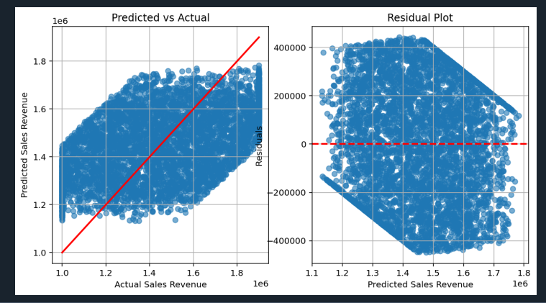

**6. Sales Forecast**

We asked the model to predict next month's sales. We assumed we would **increase marketing spend by 10%** and keep everything else the same as last month.

* **Predicted Sales:** **$1,728,739.73**

**7. Answers to Your Key Questions**

1. How does Marketing Spend impact Sales?

It's the most important factor, period. It has the strongest link (+0.49) and the biggest impact score ($137k).

1. Does offering higher discounts always increase Sales?

No. Our current discounts are failing. They have no link to sales (–0.01) and the model shows they even hurt sales a little (–$2.3k). They are costing us money for no gain.

1. How sensitive are Sales to competitor prices?

Not sensitive at all. The data shows no link (–0.02). Our customers don't seem to be leaving us when competitors change their prices.

**8. Three Simple Recommendations**

1. **Spend More on Marketing:** This is the clearest way to grow sales. The data proves it works.
2. **Rethink All Discounts:** Stop the current discount strategy. It's not working. We should either (A) move that money into the marketing budget (which *does* work) or (B) test new *types* of promotions, like "buy-one-get-one" or loyalty rewards, to see if they can actually drive more sales.
3. **Use Marketing to Drive Store Visits:** Getting people in the door is the second-most important factor. Our marketing ads should have a clear "call to action" to visit the store, like promoting an in-store-only event or a "click and collect" service.